The mathmatical modle of the elipticals and how they work is the same idea as a double faris wheel of a point on a circle on a circle. This complex idea is seen a lot in nature and life and can be used for almost any orbital sanatio. The elipticals explane how the distance between two objects are realated as well as how much time has padded relative to distance. Using these modles we can use them to help determen important things like when to lanch rockets at other planets. Some of the things this orbit does not have are the tilts of the orbital axis of these planets. The planets in our solar system are not in a streight line.

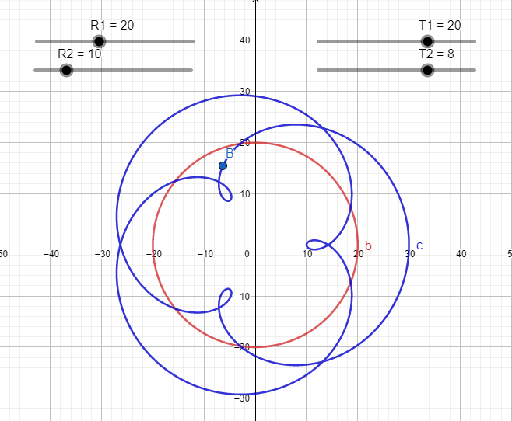 This modle can also be used bt ANY planet in relaton to another planet, or any moon in relation to another moon around the same planet. It cant be used by the sun and one of the planets or the earth and its moon because theu stay abour the same distance away all the time and would create a normal orbit.

Another situation can be used with sattern and jupitar. Jupiter is super far away from sattern yet is the closest planet. So we need to time our passing of these planets so they are closest as they can be. One way to do this is map there eliptical orbits in relation to each other.

You can also see retrograde motion on all planet further from the sun than earth. This is a consistant idea that works all the time.

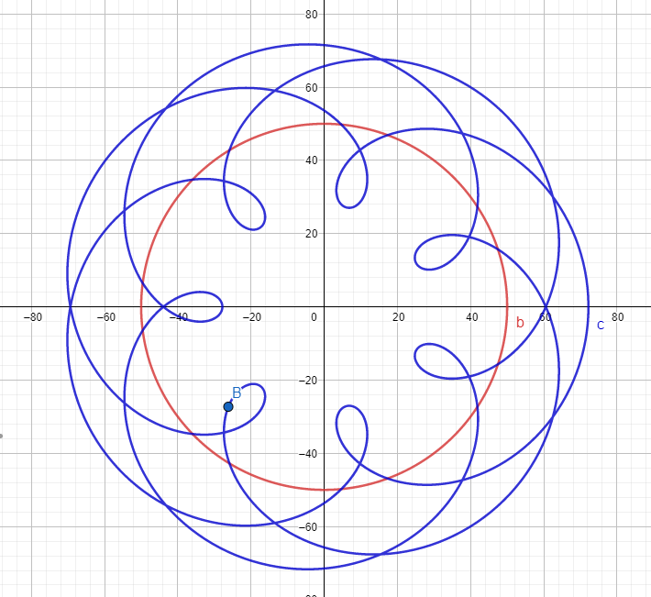Yes anyone can try to recreate these basic ideas and they will be true, this is how we debuck flat earth as well as a solarsyrem with the earth in the middle. These ideas will always be true because of how our solar system works.